**TOAD Data Modeler – Reverse Engineering (Chinook DB)**

MySQL Database

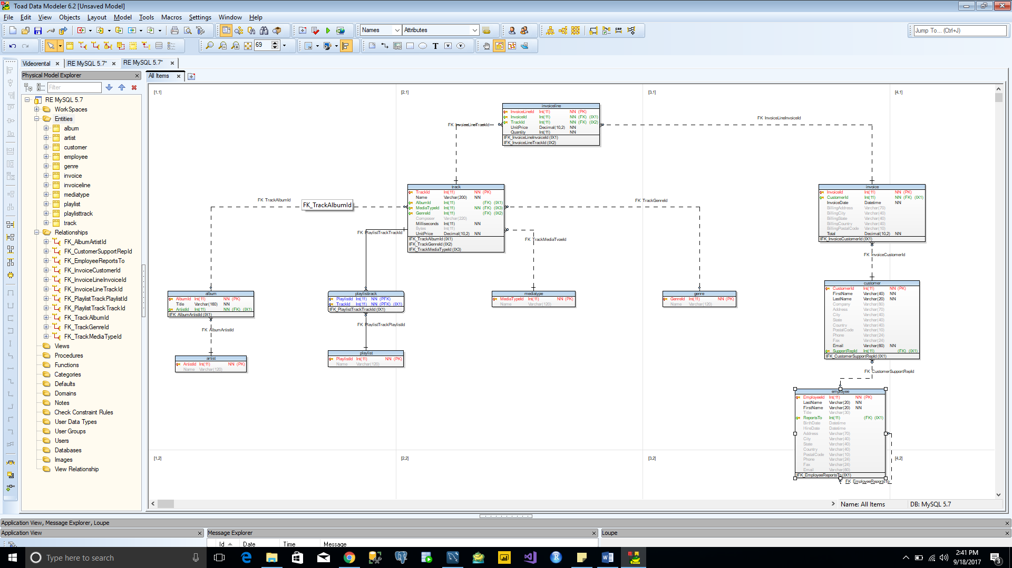

SQL server Database

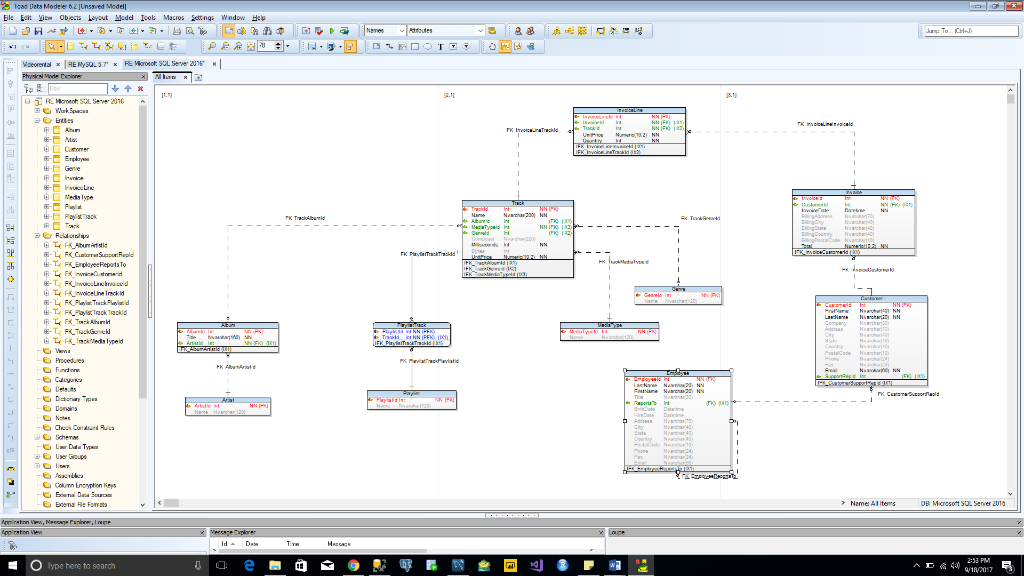

Oracle Database

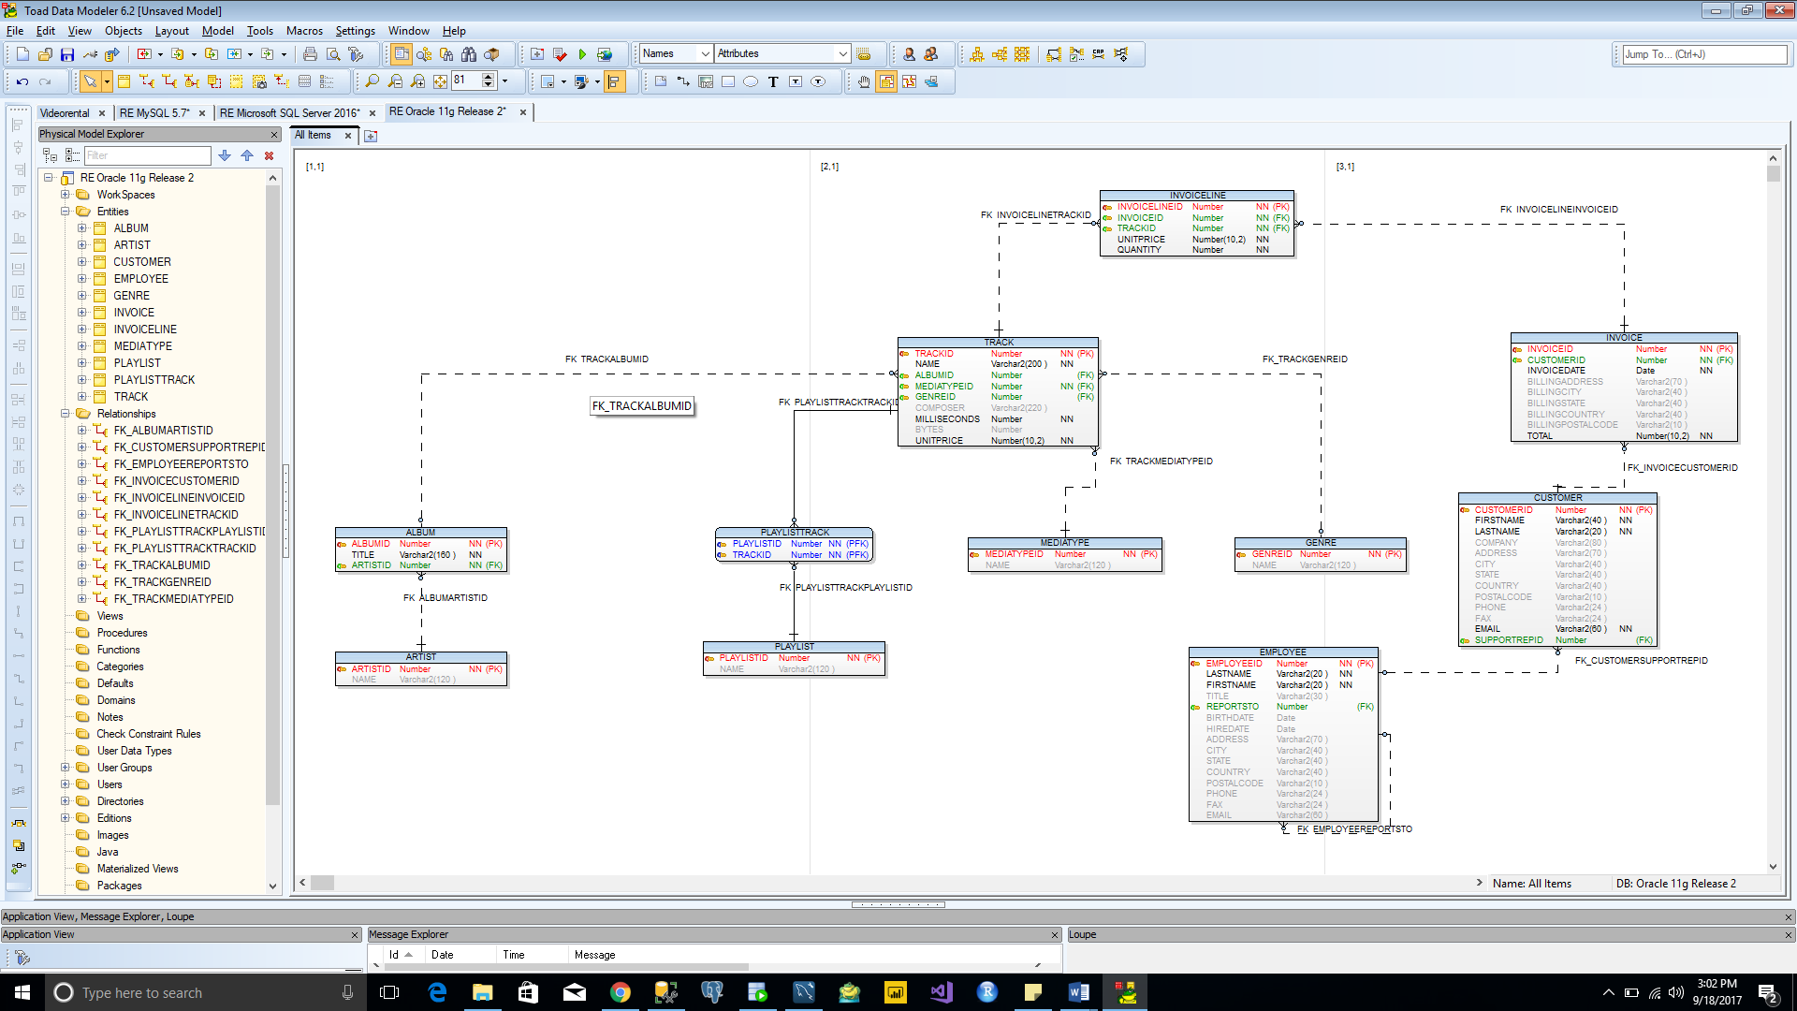

PostgreSQL Database

